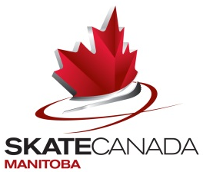

Media Release

Twelve of Manitoba’s top skaters descend on Edmonton AB to compete in the 2016 Skate Canada Challenge

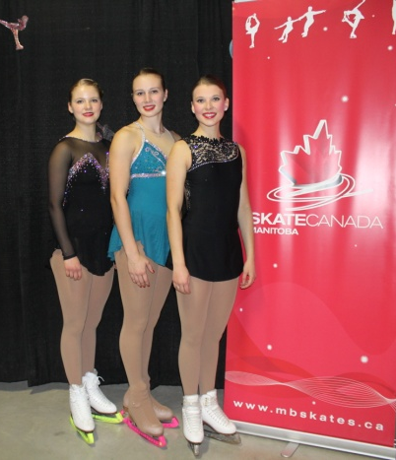
FOR IMMEDIATE RELEASE

WINNIPEG, MB. Nov. 30, 2015
Skate Canada Manitoba is sending 12 skaters to Edmonton, Alberta to compete in the 2016 Skate Canada Challenge Competition, the skaters will be competing starting Wednesday Dec 2 – Sunday Dec 6th in Pre-Novice Women, Novice Women, Junior Women and Senior Women.

Approximately 500 skaters from across Canada will be competing in 16 categories; at the end of the weekend Skate Canada will crown the Pre-Novice Canadian Champion in each of the 4 disciplines (singles {women & men}, ice dance and pairs). Skaters in Novice, Junior and Senior will be vying for a berth to the 2016 Canadian Tire National Skating Championships Jan 22-24th in Halifax, Nova Scotia.
MB Junior Women

The competition schedule, start orders and live streaming information is available at Skate Canada’s website www.skatecanada.ca

2016 Skate Canada Manitoba - Challenge Team

Category | Name | Club | Coach
Pre-Novice Women | Andrea Laskovic | Skate Winnipeg | Roni Swischuk
 | Emma King | Skating Winnipeg | Margo Russell
 | Julia Patenaude | Holland Figure Skating Club | Tammy McKay
 | Chanel Cabak | Portage Skating Club | Margo Russell
Novice Women | Casey Bertholet | Hartney Figure Skating Club | Tammy McKay
 | Dominique Bergeron | Portage Skating Club | Anna-Bell Langois-Hay & Cody Hay
 | Danae Russell | Skate Winnipeg | Margo Russell
 | Lindsey Hopkins | Selkirk Skating Club | Margo Russell
Junior Women | Madison McCallum | Skate Brandon | Tammy McKay
 | Tori Thiessen | Skate Brandon | Tammy McKay
 | Kirsten Gutenberg | Skate Brandon | Tammy McKay
Senior Women | Deidre Russell | Skating Winnipeg | Margo Russell
Team Leaders | Marj Beddall
 | Mary Ellen McDonald

-30-
For more information – contact Shauna Marling, Executive Director skate.exec@sportmanitoba.ca or 204-925-5708 (W), Monday – Friday 8:30 am – 4:30 pm.

