MEDIA RELEASE
Top Manitoba Figure Skaters Heading to the 2016 Skate Canada Challenge
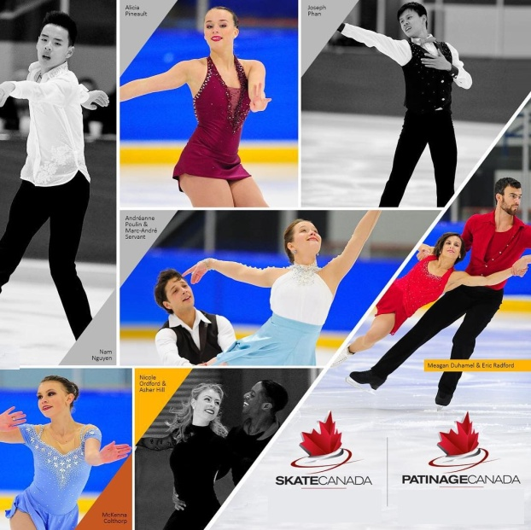
FOR IMMEDIATE RELEASE
November 8, 2015
WINNIPEG, MB - On November 7-8, Manitoba’s newest High Performance Figure Skating Team was identified at the 2016 Skate Canada Manitoba Sectional Championship, held at the Morris Multiplex, in Morris, MB. Manitoba’s top skaters were vying for a spot to compete at the 2016 Skate Canada Challenge Competition in Edmonton, Alberta.
In Edmonton, Manitoba’s skaters will compete against the rest of the country’s best skaters at the 2016 Skate Canada Challenge (December 2 —6, 2015 at the Terwillegar Community Recreation Centre).
The competition will feature Pre-Novice, Novice, Junior and Senior level skaters in Men’s, Women’s, Pairs and Ice Dance. Approximately 500 skaters from across the country will compete at this flagship event.
This is the only opportunity for Novice, Junior and Senior skaters to qualify for the 2016 Canadian Tire Figure Skating Championships, in Halifax, N.S., from January 22-24, 2016.
The following skaters are now members of our 2015- 2016 Skate Canada Manitoba Team TOBA High Performance Team and will be representing our province this season:
Senior Women Junior Women
Deidre Russell – Skate Winnipeg Madison McCallum – Skate Brandon
Tori Thiessen – Skate Brandon
Kirsten Gutenberg – Skate Brandon

Novice Women Pre-Novice Women
Casey Bertholet – Hartney Figure Skating Club Andrea Laskovic – Skate Winnipeg
Dominique Bergeron – Portage Skating Club Emma King – Skate Winnipeg
Danae Russell – Skate Winnipeg Julia Patenaude – Holland Figure Skating Club
Lindsey Hopkins – Selkirk Skating Club Chanel Cabak – Portage Skating Club
Nicole Nordal – Skate Winnipeg Marijka Popadynetz

Pre-Novice Men
Mason Panko – Portage SC
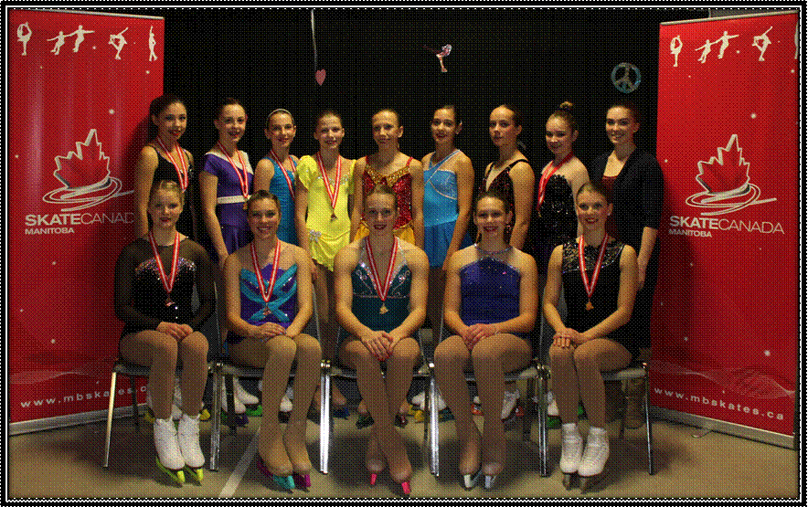
2015-16 HP TEAM PHOTO

Additionally, our up and coming skaters competed in Pre-Juvenile and Juvenile figure skating events and the top 4 placements are.

Pre-Juvenile Women U11 Pre-Juvenile Women U13
Olivia Sawatzky – Morden Figure Skating Club Caitlyn Stevenson – Skate Brandon
Lilly MacInnis – Skate Brandon Dana Hynes – Morden Figure Skating Club
Breken Brezden – Skate Dauphin Chloe Howell – Arborg Skating Club

Pre-Juvenile Men U13 Juvenile Men U12
Jonathan Scherr – Morden FSC Yohnatan Elizarov – Skate Winnipeg

Juvenile Women U12 Juvenile Women U14
Megan Szabo – Skate Thompson Olivia Orbanski – Arborg Skating Club
Robyn Ward – Century Skating Club Morgan Haerer – Hartney Figure Skating Club
Kylie Holmstrom – Skate Virden Charlotte Kowall – Skate Winnipeg

Juvenile Dance
Ranae Cabak/Mason Panko – Portage SC

-30-
For more information regarding the skaters and this event please go to www.mbskates.ca or contact Shauna Marling, Executive Director, Skate Canada Manitoba, (204) 925-5708 or skate.exec@sportmanitoba.ca (M-F 8:30 – 4:30 pm)

