Media Release

Carberry Skating Club and Skate Canada Manitoba to Host the
2016 Manitoba Synchronized Skating Championships on January 16, 2016

FOR IMMEDIATE RELEASE
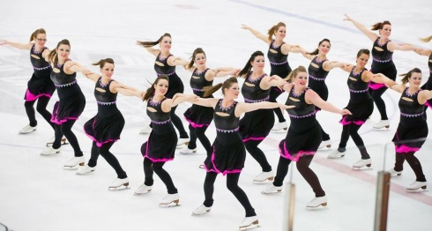
WINNIPEG, MB. January 4, 2016 - Kim Baron, Event Chairperson is pleased to announce the Carberry Skating Club and the Skate Canada Manitoba Section are hosting the 2016 Skate Canada Manitoba Synchronized Skating Championships at the Carberry Plains Community Centre Arena on January 16, 2016.

Shauna Marling, Executive Director Skate Canada Manitoba thanked the Carberry Skating Club and its volunteers for hosting this exciting and fun event. Marling explained that synchronized skating is a specialized discipline of skating involving groups of eight or more skaters performing various group formations and maneuvers. The objective is for the team to perform as one unit by executing circles, blocks, lines, wheels and intersections in unison to the music while demonstrating quality edges, power and flow. Marling added Synchronized Skating is very exciting and fun to watch.

Over one hundred and fifty skaters ages 6 to adult on 17 teams, from all across Manitoba will compete in events from Beginner I and Elementary through Pre-Novice and Adult II.

The Carberry Skating Club invites everyone to attend this competition and enjoy some excellent Synchronized Skating.

Tickets for the Skate Canada Synchronized Skating Sectionals Manitoba Competition are available at the Carberry Plains Community Centre Arena. Practice skates and competition schedules will be available on the Skate Canada Manitoba website http://sec0manitoba.wpengine.com/competitions-3/synchro-championships/

Admission to this competition is Adults $5.00; Seniors & 12 and under $3.00; 5 and under – free. Programs will be available for $2.00

-30-

For more information – contact Shauna Marling, Executive Director skate.exec@sportmanitoba.ca or 204-925-5708 (W), Monday – Friday 8:30 am – 4:30 pm.
OR
On the weekend – Kim Baron, Event Chairperson at 204-476-4766 (cell) or redb@inetlink.ca.

