Media Release:
Learn to Skate with CanSkate in 2016-17
FOR IMMEDIATE RELEASE

WINNIPEG, MB Sept. 7, 2016

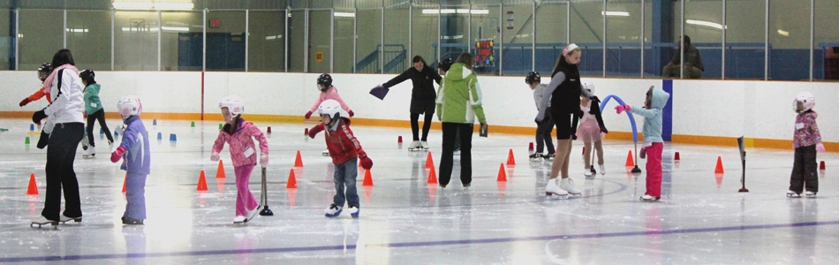

CanSkate is Skate Canada's flagship Learn-to-Skate Program, designed for beginners of all ages. When you sign up for CanSkate with a Skate Canada Manitoba Skating Club, you will be in a program that focuses on fun, participation and basic skill development. To find a club hosting a “free” CanSkate session go to www.mbskates.ca and click on “Our Skating Clubs”. The free Skate Canada Manitoba Day session will vary at each club – most are offering a session during September or October.

Skate Canada Manitoba Skating Clubs are entering into their third full year of teaching Skate Canada's new CanSkate program, based on Sport Canada’s long term athlete development (LTAD) principles. Exciting new features include a fresh new look, new awards, great tools for coaches and most importantly a tested and proven new curriculum and delivery methods that guarantee skater success in developing stronger basic skills and developing them faster. But there’s more! The new program also includes specific skills that pertain to hockey, ringette, speed skating and figure skating. The result is a dynamic new program that prepares all skaters for virtually every ice sport.

Who’s it for?
For beginners of all ages, children or adults, as well as for those wishing to improve their basic skills whether their focus is for figure skating, hockey, speed skating or just skating for fun.

Who teaches it?
National Coaching Certification Program (NCCP)-trained professional coaches, assisted by trained Program Assistants.

What will you learn?
A complete series of balance, control and agility skills taught in six stages of learning that pertain to hockey, ringette, speed skating and figure skating as well as general recreational skating. CanSkate uses nationally-tested and proven curriculum and delivery methods that guarantee skater success in developing stronger basic skills and developing them faster.

What can you expect?
Action, movement and fun! Lessons are given in a group format with a coach-to-student ratio of a maximum 1:10. Skaters progress at their own rate and coaches make sessions active using teaching aids, upbeat music and a wide variety of activities that create a motivational environment and promote learning. Badges, ribbons and other incentives are used to benchmark skaters’ progress and reward effort and participation.

What do you need to participate?
All you need are skates, a CSA-approved hockey helmet, long pants, mittens, warm sweater or jacket. Dress in layers – it will get warm!

What does CanSkate look like?
Check out Skate Canada's new CanSkate YouTube video:

https://www.youtube.com/watch?v=9Z7KBWwpVgU

How to Sign-up?
To sign-up for CanSkate go to the following link to locate a Skate Canada Manitoba Skating Club near you!

http://sec0manitoba.wpengine.com/about-us/our-skating-clubs/

Who is hosting a free CanSkate Session (Skate Canada Manitoba Day)?

http://sec0manitoba.wpengine.com/clubs-schools/workshops-clinics-seminars/skate-canada-manitoba-day/

-30-
For information on this program or other Skate Canada or Skate Canada Manitoba please contact Shauna Marling, Executive Director at skate.exec@sportmanitoba.ca or at 204-925-5708.

Skate Canada – www.skatecanada.ca
Skate Canada Manitoba – www.mbskates.ca

