MEDIA RELEASE

Skate Canada Manitoba announces their 2019 Award Winners recognizing Skaters, Coaches, Officials and Volunteer Excellence
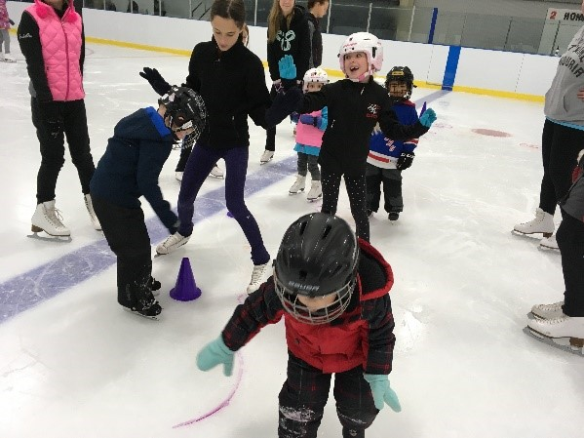
FOR IMMEDIATE RELEASE

WINNIPEG, MB. March 21, 2019 - Skate Canada Manitoba will be holding their annual Awards Gala evening on Saturday April 27th at the Victoria Inn Hotel and Convention Centre in Winnipeg Manitoba, to celebrate our award recipients. Donna Yee, Chair of Skate Canada Manitoba stated, “this is the time of the year when our organization gathers to recognize the successes of our skaters, coaches, and officials and to thank our many dedicated volunteers”.

The first set of recipients were selected from nominations submitted by our members throughout the province in skater, coach and volunteer categories;

Skate Canada Manitoba CanSkate Athlete Award – Haleigh Cuvelier from Skate Brandon
Skate Canada Manitoba STARSkate Athlete Award – Melissa Kerik from Skate Brandon
Skate Canada Manitoba CompetitiveSkate Athlete Award – Annika Duguay from the Carberry Figure Skating Club
Skate Canada Manitoba Program Assistant Award – Cassidy Miller from Skate Brandon
Skate Canada Manitoba Volunteer Award – Marlow Gwynne from Skate Brandon
Skate Canada Manitoba Volunteer Coach Award – Cynthia Chartrand from the Neepawa Figure Skating Club
Skate Canada Manitoba Volunteer Award of Excellence – Don Brown from the East St. Paul Figure Skating Club

Several other award/bursary recipients were also announced;

Ian Carmichael Memorial Award winner is Andrea Laskovic from Skate Winnipeg
Dodie Wardle Memorial Award winner is Sadie Graetz from Skate Winnipeg
Manitoba Open Junior Artistic Award winner is Ava Kemp from Skate Winnipeg
Manitoba Open Senior Artistic Award winner is Olivia Sawatsky from the Morden Figure Skating Club
Manitoba Open Bursaries awarded to Sloane Walker from Skate Winnipeg, Ava Kemp from Skate Winnipeg, Jade Pilat from the East St. Paul Figure Skating Club, Davie Howes from Skate Winnipeg, Emmet Dewar from the East St. Paul Figure Skating Club and Marius Peter-Joyal from Skate Winnipeg

Congratulations to all our recipients for their dedication and hard work.

-30-

For more information – contact Shauna Marling, Executive Director skate.exec@sportmanitoba.ca or 204-925-5708 (W), Monday – Friday 8:30 am – 4:30 pm.

